# 

**Temenos XAI Platform**

**Lab Guide**



# Table of Contents

Document History 2

How to use this template 2

Disclaimers 2

Viewing styles 2

Adding numbered and bulleted text 2

Numbered text 2

Bulleted text 2

Adding tables 2

Adding screen shots/diagrams 2

Adding other styles 2

# Document History

|  |  |  |
| --- | --- | --- |
| Author | Version | Date |
| Gonzalo Ruiz | 1.0 | 2020-09-24 |

Comments:

|  |
| --- |
| {Add any comments here} |
|  |
|  |

# Predictive Analytics pipeline

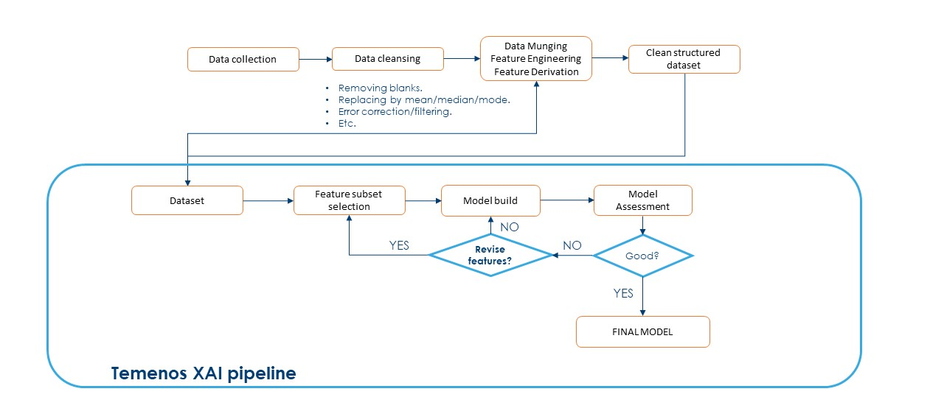

# Temenos XAI Platform pipeline

# 

# 

# Module 1: Creating a project

|  |  |
| --- | --- |
| Purpose: | Creating a project. |
|  |  |
| Tasks: | In this module you will be creating a binary classification project from a CSV file and making sure it is ready to work with. |

| Step | Action |
| --- | --- |
| 1 | **Landing page and create new project** |
| 2 | **Upload Wizard**  **(I)**    **(II)**    **(III)**    **(IV)** |
| 3 | **Project overview** |
| 4 | **Audit** |
| 5 | **Partitioning** |

## Module 1: Lab Summary

In the first module we created a project, explored the audit warnings and set up the partitioning, so we are ready to build models.

At this point we will move on to Part 2 where we will focus on selecting features.

# Module 2: Selecting features

|  |  |
| --- | --- |
| Purpose: | Choosing features to build a model |
|  |  |
| Tasks: | In this module you will be creating features sets, both manually and through feature selection, in order to build models. |

# Feature Selection workflow

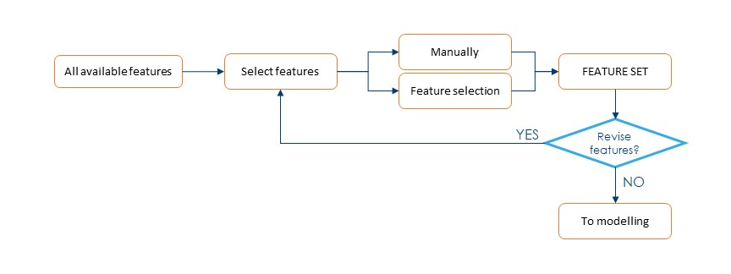

| Step | Action |
| --- | --- |
| 1 | **Manually creating a feature set** |
| 2 | **Feature Selection**  **(I)**    **(II)**    **(III)** |

# Module 3: Building models – Focus on XAI

|  |  |
| --- | --- |
| Purpose: | Building predictive analytics models |
|  |  |
| Tasks: | In this module you will be creating models from the features prepared in the previous modules. We will focus con Explainable models. |

| Step | Action |
| --- | --- |
| 1 | **Building models in 1-click** |
| 2 | **Configuring the hyperparameters (Fuzzy Logic)** |
| 3 | **Model Summary** |
| 4 | **Bucketing**  **(I)**    **(II)**    **(III)** |

# Module 4: Model life cycle and monitoring

|  |  |
| --- | --- |
| Purpose: | Understand the representation of a model’s life cycle and how to monitor its performance. |
|  |  |
| Tasks: | In this module you will learn about a model’s life cycle in the context of your Organisation, and how to monitor its performance over time |

| Step | Action |
| --- | --- |
| 1 | **Model life cycle in Temenos XAI Platform** |
| 2 | **Monitoring model’s performance – Bulk Inference**  **(I)**    **(II)** |
| 3 | **Population Stability** |
| 4 | **Characteristic stability** |

# Module 5: Interpretability

|  |  |
| --- | --- |
| Purpose: | Understand the different levels of interpretability of XAI models. |
|  |  |
| Tasks: | In this module you will learn about the three different levels of interpretability that can be obtained through an XAI model:   * Population level. * Subpopulation level. * Individual level. |

| Step | Action |
| --- | --- |
| 1 | **Interpretability at Population level: the rule base** |
| 2 | **Interpretability at subpopulation level: click-through-bucketing** |
| 3 | **Interpretability at individual level: single inference**  **(I)**    **(II) A “good” decision**    **(III) A “Bad” decision** |

# Module 6: Actionable Insights

|  |  |
| --- | --- |
| Purpose: | How to perform “what if” scenarios. |
|  |  |
| Tasks: | In this module you will learn how to harness XAI models and their explainability to evaluate “what if” scenarios. |

| Step | Action |
| --- | --- |
| 1 | **Borderline decision – Can I change anything?** |
| 2 | **Negative feature contribution – FICO Credit Score** |
| 3 | **What if I changed the value?**  **(I)**    **(II)**    **(III) A “Bad” decision** |

# Module 7: Including expert knowledge.

|  |  |
| --- | --- |
| Purpose: | How to include domain-specific knowledge into XAI models. |
|  |  |
| Tasks: | In this module you will learn how to use the “Scenario” functionality, allowing you to include expert domain knowledge into XAI models. |

| Step | Action |
| --- | --- |
| 1 | **Scenarios - Including your own rules**  **(I)**    **(II)**    **(III)** |

# Module 8: Deployment and pipelines.

|  |  |
| --- | --- |
| Purpose: | Inform the user on how to deploy single models or cascaded pipelines. |
|  |  |
| Tasks: | This module is just informative, in order to let the user know how to use deployed models in isolation or within a cascaded pipeline. |

| Step | Action |
| --- | --- |
| 1 | **API – Model-specific auto-generated documentation** |
| 2 | **Cascading models into complex pipelines** |